IOT development and Future
Speaker, Zhengwei Wang
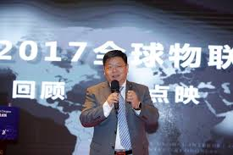
Abstract: The Internet of Things is an important part of the new generation of information and communication technology. This talk will present the challenges and opportunities faced by the global Internet of Things industry; the history and progress of China Zhongguancun Internet of Things Alliance (Z-IoT) and its national and international cooperation in various industries such as intelligent manufacturing, autonomous driving, and smart cities.
Biography
Mr. Zhengwei Wang is the president of Z-park Internet of Things Industry Alliance, Director of Z-Park Internet of Things Industry Innovation Centre, Co-founder of Z-Park Internet of Things Industry Foundation. Before joining ZIOTA, Mr. Wang set up the first professional IoT Media Magazine in China – “China Information – Internet of Things”. Mr. Wang worked as Marketing Director Asia Pacific of AT&T and Managing Director the China Branch of one Hong Kong Listed Company. Mr. Wang is an expert in Communication, Internet, Software and System Integration Industries with more than 20 years’ experience in business management,. Mr. Wang has participated in several national level research projects as a leader, and received several awards such as the “2006 Innovation Prize of China Government” and the "2006 Top 10 Internet Innovation Prize”.

