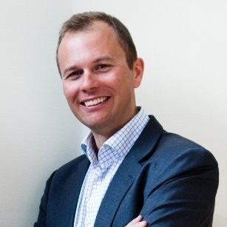
Peter Feiring, Regional Manager Finland & Baltics, Tele2 IoT:

Peter has extensive experience from high tech field. He has worked for Nokia from 2000 to 2012, TeliaSonera from 2013 to 2016 and at Tele2 from 2016 to present. His titles have varied from R&D manager to regional sales manager. Among his key expertise areas are mobile communications, mobile technology & devices and telecommunications industry knowledge.

